

Event Capture V. 2.0

Graphical User Interface (GUI)

Patch EC*2.0*100

Installation guide

January 2010

Department of Veterans Affairs
Office of Information and Technology (OI&T)
Office of Enterprise Development (OED)

Table of Contents

1 Introduction 1
1.1 Purpose 1
1.2 Scope 1
1.3 Acronyms 2
2 Install Requirements 3
2.1 Package Integration 3
2.2 Server Requirements 3
2.3 Client Requirements 3
3 Server Installation 5
3.1 Installation Example 6
4 Client Installation 9
4.1 RPC Broker 9
4.2 Command Line Parameters 9
4.3 ECS GUI Client Installation 10
4.4 Accessing ECS GUI via CPRS 16
4.4.1 Instructions 16

Introduction

Purpose
The purpose of this Installation Guide is to provide details on the installation of Event Capture System (ECS), Graphical User Interface (GUI), Patch EC*2.0*100, software. The intended audience includes Technical Services, National VistA Support and Software Quality Assurance.

Scope
EC*2*100 provides a Graphical User Interface to the ECS application. It offers the current roll-n-scroll functionality in a well-organized and user-friendly GUI environment. This promotes the collection and reporting of accurate workload information to the Decision Support System (DSS). Additionally, ECS GUI allows sites to upload patient encounter data from a spreadsheet into Event Capture. The GUI design is consistent in look and feel with current VistA GUI applications.

ECS GUI offers the following features.

- Allows users to:

- enter multiple dates/multiple procedures
- batch enter data by patient or procedure
- access on line help for the software
- print the following reports
Patient Summary Report
DSS Unit Workload
Provider Summary Report
Ordering Section Summary Report
PCE Data Summary Report
Inactive Person Class Report
Procedure Reason Report
- upload patient encounter data to Event Capture from a spreadsheet
- switch between CPRS and ECS via the use of a hot button in the tools menu of either application

- Allows management users to:

- create/remove current locations
- enter/edit DSS Units
- assign/remove user access to DSS Units
- enter/edit local category or procedure
- create event code screens
- enter/edit procedure synonym and default volumes
- inactive event code screens
- activate/inactivate local procedures and categories
- Create/print the following reports
National/Local Procedures Report
Category Report
Print Category and Procedure Summary

Acronyms
ECS Event Capture System
GUI Graphical User Interface
HFS Host File Server
IG Installation Guide
RPC Remote Procedure Call
VA Department of Veterans Affairs
VISTA Veterans Health Information Systems and Technology Architecture

Install Requirements

Package Integration
The following package versions (or higher) must be installed prior to loading this patch of Event Capture.

Kernel 8.0
Toolkit 7.3
Event Capture 2.0
RPC Broker 1.1
MailMan 7.1
VA FileMan 22.0

Server Requirements
Any site not currently running the Event Capture Software application and wishing to install ECS GUI must install all previous EC patches. For details on how to install the previous EC patches, please refer to the corresponding patch descriptions and EC 2.0 Installation guide.

Each user will also need to have the option EC GUI CONTEXT added to their secondary menu.

Client Requirements
ECS GUI may be run in a test environment before installation, but it is not necessary. Event Capture runs on the standard hardware platforms used by Department of Veterans Affairs Healthcare facilities. These systems consist of Alpha AXP running DSM or Alpha/NT running Open M.

To run this Delphi-based application, the following is recommended.

- Intel Pentium 90 or higher (P166 recommended)
- Microsoft Windows 95, 98, or NT 4.0 with Service Pack 3 or later
- Memory: 32MB of RAM (64MB or more recommended)
- Hard disk space: 6MB
- VGA or higher resolution monitor
- Mouse or other pointing device
- Networks supported: Any Microsoft Windows 95, 98, or Windows NT or higher compatible network

Server Installation

The following are instructions for installing the Kernel Installation & Distribution System (KIDS) Build of the ECS GUI application. This patch should be loaded during non-peak hours to minimize disruption to users on the system. Installation will take less than 10 minutes.

- Use the INSTALL/CHECK MESSAGE option on the PackMan menu to unload the KIDS distribution.
- Review your mapped set. If any of the routines listed in the ROUTINE SUMMARY section are mapped, they should be removed from the mapped set at this time.
- From the Kernel Installation and Distribution System (KIDS) Menu, select the Installation menu.
- From this menu, you may elect to use the following options (when prompted for INSTALL NAME, enter EC*2.0*100).
a) Backup a Transport Global – This option will create a backup message of any routines exported with the patch. It will NOT backup any other changes such as DDs or templates.
b) Compare Transport Global to Current System - This option will allow you to view all changes that will be made when the patch is installed. It compares all components of the patch (routines, DDs, templates, etc.).
c) Verify Checksums in Transport Global - This option will allow you to ensure the integrity of the routines that are in the transport global.
d) Print Transport Global - This option will allow you to view the components of the KIDS build.
- Use the Install Package(s) option and select the package EC*2.0*100.
- When prompted, "Want KIDS to INHIBIT LOGONS during install? Yes//", respond "NO".
- When prompted, “Want to DISABLE Scheduled Options, Menu Options, and Protocols? YES//”, respond YES. When prompted to select the options you would like to place out of order, enter the following: Event Capture Menu ... [ECMENU]
- If a routine was unmapped as part of Step 2, it should be returned to the mapped set once the installation has run to completion.
- Upon completion of the installation, place the User and Technical Manual files in a location that can be accessed by all EC users.

Installation Example
Select Installation Option: 6 Install Package(s)
Select INSTALL NAME: EC*2.0*100 Loaded from Distribution 1/5/10@13:20:31
=> ECS FY09 ENHANCEMENTS EC*2.0*100 (1/5/10)

This Distribution was loaded on Jan 05, 2010@13:20:31 with header of
ECS FY 09 ENHANCEMENTS EC*2.0*100 (1/5/10)
It consisted of the following Install(s):
EC*2.0*100
Checking Install for Package EC*2.0*100
Will first run the Environment Check Routine, EC2P100

Install Questions for EC*2.0*100

Incoming Mail Groups:

Enter the Coordinator for Mail Group 'ECMGR': ECMANAGER,ONE// EO
-- COMPUTER SPECIALIST

Want KIDS to Rebuild Menu Trees Upon Completion of Install? NO//

Want KIDS to INHIBIT LOGONs during the install? NO// y YES
Want to DISABLE Scheduled Options, Menu Options, and Protocols? NO// YES

Enter options you wish to mark as 'Out Of Order': EC GUI CONTEXT EC GUI Co
ntext version 2.1.3.2

Enter options you wish to mark as 'Out Of Order':

Enter protocols you wish to mark as 'Out Of Order':

Delay Install (Minutes): (0-60): 0//

Enter the Device you want to print the Install messages.
You can queue the install by enter a 'Q' at the device prompt.
Enter a '^' to abort the install.

DEVICE: HOME// VIRTUAL TELNET

Install Started for EC*2.0*100 :
Jan 05, 2010@13:26:21

Build Distribution Date: Nov 05, 2009

Installing Routines:
Jan 05, 2010@13:26:21
Installing PACKAGE COMPONENTS:

Installing PRINT TEMPLATE

Installing SORT TEMPLATE

Installing MAIL GROUP

Installing REMOTE PROCEDURE

Installing OPTION

Installing PARAMETER DEFINITION
Jan 05, 2010@13:26:21

Running Post-Install Routine: POST^EC2P100

EC PCE FEED ** Menu option disabled **

>>> Adding users with the ECXMGR key to ECMGR Mailgroup...

EC*2.0*100
────────────────────────────────────────────────────────────────────────────────
Installing Event Capture Object Factory Parameters
EC OBU UTILITY... published
EC OBU UTILITY LIST... published
EC OBU LAST USED... published
EC DSS UNIT TABLE... published
EC VISIT... published
EC VISITS... published

Updating Routine file...

Updating KIDS files...

EC*2.0*100 Installed.
Jan 05, 2010@13:26:22

Not a production UCI

NO Install Message sent
────────────────────────────────────────────────────────────────────────────────
┌────────────────────────────────────────────────────────────┐
100% │ 25 50 75 │
Complete └────────────────────────────────────────────────────────────┘

Install Completed

Client Installation

RPC Broker
The assumption is made that the user’s PC has the required RPC Broker Client Workstation set up. If this is not the case, the user should first install this software. The installation is beyond the scope of this Installation Guide, but the RPC Broker files and installation instructions can be found on the VA’s RPC Broker web page. These files must be installed before running the ECS GUI application.

Command Line Parameters
Note: The parameters may be in any order. Parameters S and P are a set, i.e., they must both be present or they will be ignored.

Parameter Example (Default) Description

S= S=BrokerServer The name of the ECS GUI BrokerServer as defined in the
Hosts file. The default is 'BrokerServer'.

P= P=nnnn The ServerPort used by the ECS GUI BrokerServer.
Example P=9200.

ECS GUI Client Installation
The ECS GUI.exe software can be copied to each PC or accessed on a network drive. Do not place the executable directly on the desktop.

Follow these instructions to install ECS GUI on the client machine.

- Double Click on EC2_0P100.EXE. This will launch the InstallShield Wizard. When
prompted to install the ECS GUI application, answer YES. For some users this screen may not appear. If this is case, the following screen will be the first one that they see.

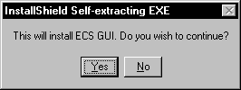

- When the “Welcome” screen is displayed, click "Next".

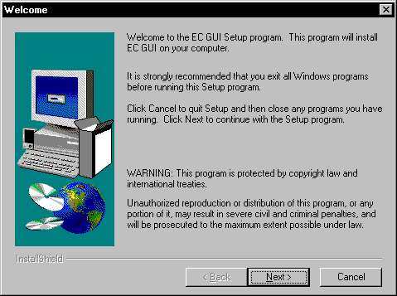

- On the “Choose Destination Location” screen, specify the path using the following format: Drive:\Program Files\VistA\ECS GUI. Click "Next" and the directory will be created.

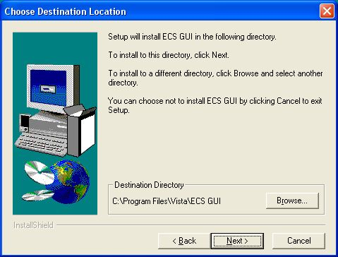
- On the "Setup Type" Screen, select one of the following:

Typical installs both the ECS GUI client program and ECS documentation.
Compact installs only the ECS GUI client program.
Custom allows you to select which programs and files to install, including the RPC
Broker ServerList utility and spreadsheet samples (see next screen).

Typical is selected by default. Click "Next".

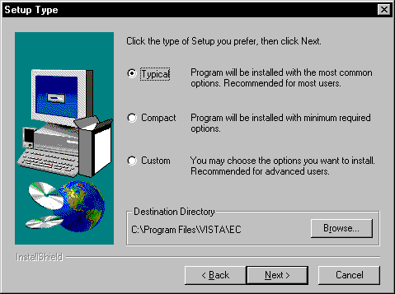

- If you selected the ‘Custom’ install, you can select which components you want to install. Click “Next” after you’ve made your selection(s).

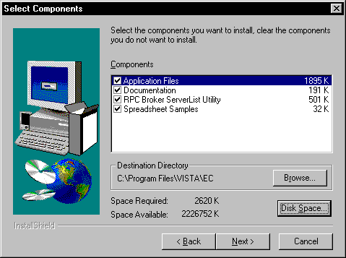

- On the “Select Program Folder” screen, let it default to the ECS GUI program Folder and click “Next”.

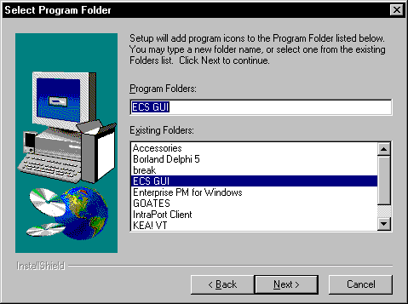
- On the “Start Copying Files” screen, review the information and click "Next.”

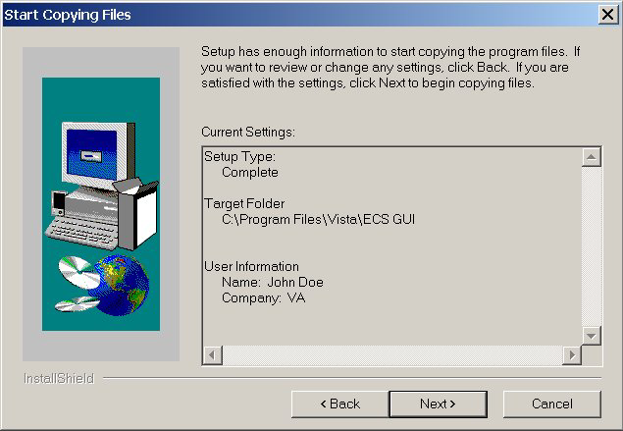

- The ECS GUI will be installed and the “Setup Complete” screen will be displayed. Click "Finish" and the ECS GUI installation is now complete. NOTE: It is not necessary to reboot your machine after the installation.

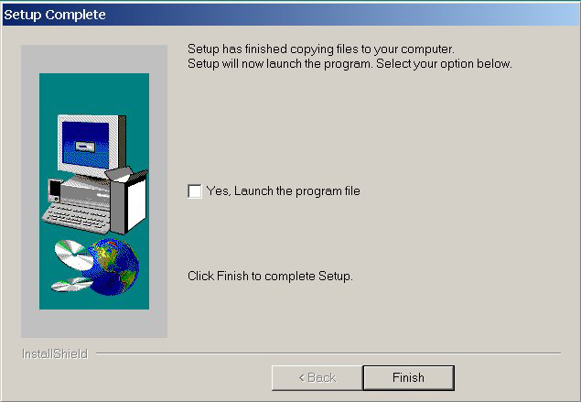

Accessing ECS GUI via CPRS
It is possible to set up a “hot button” that will allow you switch back and forth between the CPRS and ECS applications. The button can be placed in the Tools menu of CPRS GUI. Within CPRS, the Tools menu is a place where you can place items that you want to have quick access to within this application. These items can include other parts of VistA, such as ECS.

A button that will allow a user to access ECS GUI in the CPRS Tools Menu can be created for all CPRS users or a specific user by the site’s clinical coordinator. He/She must create this button in VistA.

Instructions

Note: Parentheses denotes abbreviations that can be entered instead of entering the full name of the option.

- From the CPRS Configuration Menu for Clinical Coordinators, enter GUI Parameters (GP) at the prompt.
- From the list of options given, enter GUI Tool Menu Items (TM) at the prompt.
- From the list of options given, enter Package (9). NOTE: By choosing this option you are giving this functionality to all users. If you want to give this functionality to one user choose User (1) instead.
- The user will receive two messages; one regarding the parameters set for ‘Package’ and the other for the Setting of the CPRS GUI Tools Menu for Package.
- The user will be asked to select a sequence. Type a question mark to get a choice of options.
- Enter a number higher than the last option to add a new option.
- When asked if you are adding a new option, enter YES.
- When prompted for a “Name=Command” enter: &Event Capture="c:\program files\vista\ec\ecs gui.exe"
- When asked to select a sequence again, press ‘enter’ to get out of prompt.
Example

AU Auto-DC Parameters
AL Allocate OE/RR Security Keys
KK Check for Multiple Keys
DC Edit DC Reasons
GP GUI Parameters ...
MI Miscellaneous Parameters
NO Notification Mgmt Menu ...
OC Order Checking Mgmt Menu ...
MM Order Menu Management ...
LI Patient List Mgmt Menu ...
FP Print Formats
PR Print/Report Parameters ...
RE Release/Cancel Delayed Orders
US Unsigned orders search
EX Set Unsigned Orders View on Exit
NA Search orders by Nature or Status

Select CPRS Configuration (Clin Coord) Option: GP GUI Parameters

CS GUI Cover Sheet Display Parameters ...
HS GUI Health Summary Types
TM GUI Tool Menu Items
MP GUI Parameters - Miscellaneous
UC GUI Clear Size & Position Settings for User
RE GUI Report Parameters ...

Select GUI Parameters Option: TM GUI Tool Menu Items

CPRS GUI Tools Menu may be set for the following:

1 User USR [choose from NEW PERSON]
2 Location LOC [choose from HOSPITAL LOCATION]
2.5 Service SRV [choose from SERVICE/SECTION]
3 Division DIV [choose from INSTITUTION]
4 System SYS [PERF.ISC-BAYPINES.VA.GOV]
9 Package PKG [ORDER ENTRY/RESULTS REPORTING]

Enter selection: 9 Package ORDER ENTRY/RESULTS REPORTING

Parameters set for 'Package' may be replaced if ORDER ENTRY/RESULTS REPORTING is installed in this account.

-- Setting CPRS GUI Tools Menu for Package: ORDER ENTRY/RESULTS REPORTING --
Select Sequence: ?
Sequence Value
-------- -----
1 &Time=Clock.exe
2 &Calculator=Calc.exe
3 &Windows Introduction=WinHlp32 Wind
4 &Notepad=Notepad.exe

Select Sequence: 5
Are you adding 5 as a new Sequence? Yes// YES

Sequence: 5// 5
Name=Command: &Event Capture="c:\program files\vista\ec\ecs gui.exe"

For more information on this “tools” option, consult the CPRS user guide at:

http://www4.va.gov/vdl/application.asp?appid=61

This installation installs the GUI executable on the user’s workstation at location: C:\Program Files\VISTA\EC (unless another directory was specified on the “Choose Designation Location” screen). Using Windows or NT Explorer, go to the directory location of the executable (on the user’s workstation), create a Shortcut, and paste or copy it to the user’s Desktop for convenient access to the application.

If any prior versions of the applications exist on in the user’s directory location referenced above, these should be deleted.

